Chapter 18, Solution 54.

Design a problem to help other students better understand finding the total energy in a given signal.

Although there are many ways to solve this problem, this is an example based on the same kind of problem asked in the third edition.

Problem

Given the signal f(t) = 4 e^{-t} u(t), what is the total energy in f(t)?

Solution

W_{1Ω} = 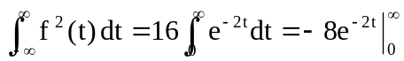 = 8 J

